 | Project Design Phase-II
 | Data Flow Diagram & User Stories
Date |  | 16 October 2022
Team ID |  | PNT2022TMID31229
Project Name |  | Project – Statistical Machine Learning
 |  | Approaches to Liver Disease Prediction
Maximum Marks |  | 4 Marks

Data Flow Diagrams:

A Data Flow Diagram (DFD) is a traditional visual representation of the information flows within a system. A neat and clear DFD can depict the right amount of the system requirement graphically. It shows how data enters and leaves the system, what changes the information, and where data is stored.
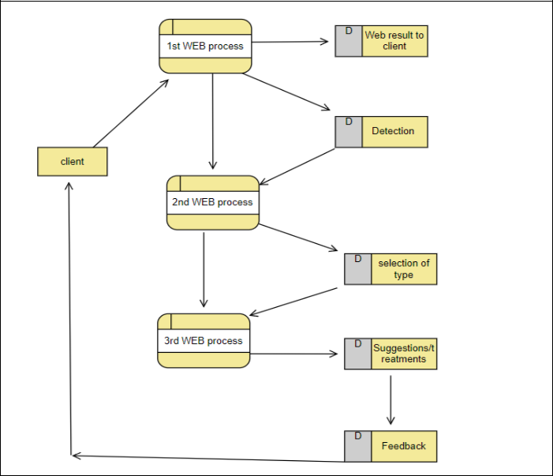
User Stories

Use the below template to list all the user stories for the product.

User Type | Functional | User Story | User Story / Task | Acceptance criteria | Priority | Release
 | Requirement | Number
 | (Epic)
Customer | Login | USN-1 | As a user, I can login for the application by | I can access my account / | High | Sprint-1
(Web User) |  |  | entering my email | dashboard
 |  | USN-2 | As a user, I will login, confirmation email once | I can receive confirmation | High | Sprint-1
 |  |  | I have registered | email
 |  | USN-3 | As a user, I can login for the application | I can login and access the | Medium | Sprint-2
 |  |  | through Mobile number | application
 | Dashboard | USN-4 | As a user, I need to enter my Details | I can get information as | High | Sprint-1
 |  |  |  | per details
 | Dashboard | USN-5 | As a user, I need to enter my Test Details | I can get result based on | High | Sprint-1
 |  |  |  | test details
Administartor | Services | USN-6 | As a admin I need to provide valid result | I can get a result | High | Sprint-1
 |  | USN-7 | As a admin I need to provide valid/useful | I can get suggestions | Medium | Sprint-1
 |  |  | Suggestions
 | Mass Data | USN-8 | As a admin need to collect all the details and | I can use it for later period | High | Sprint-1
 | Process |  | information
 |  | USN-9 | As a admin I need to store all the details and | I can use it for later period | High | Sprint-1
 |  |  | information
Hospital | Login | USN-10 | As a admin I need to login and access details | I can use for it further next | High | Sprint-1
Administrator |  |  | of customers | step process
 | Dashboard | USN-11 | As a admin I need to proceed the details with | I can use for further next | High | Sprint-1
 |  |  | case head | step process

